Phase 0 — Architecture & dataset
Days 1–2
Before writing much code:
Decide the exact data universe
I'd start with the four companies already specified in your blueprint:
- AAPL
- MSFT
- GOOGL
- NVDA
and 5–10 years of filings, as the document proposes.
Don't immediately add 100 companies.
Four companies × lots of historical filings gives you enough complexity to develop the system properly.
Database schema
I'd design something roughly like:
companies
─────────
company_id
ticker
name

documents
─────────
document_id
company_id
filing_type
filing_date
release_timestamp
source_url

chunks
─────────
chunk_id
document_id
section
page
text
embedding

financial_metrics
─────────
company_id
date
metric
value
source_document
And this will eventually make the risk engine much easier.

Phase 1 — SEC ingestion
Days 3–6
Your blueprint starts here, using edgartools and structural chunking.
Build:
SEC
↓
10-K / 10-Q
↓
parse
↓
identify sections
↓
chunk
↓
metadata
↓
PostgreSQL / JSON
The important thing is don't blindly chunk every 500 tokens.
Preserve:
AAPL
10-K
2022-10-28
Item 1A
Risk Factors
page 12
chunk 43
That metadata becomes incredibly valuable later.

Phase 2 — Entity resolution
Days 7–9
The blueprint proposes mapping phrases such as:
"the iPhone maker"
to:
AAPL
using a bi-encoder/entity-resolution system.
I'd actually start simpler.
V1
Dictionary + aliases + NER.
Apple
Apple Inc.
the iPhone maker
Cupertino giant
Apple's
↓
AAPL
Then build the ML bi-encoder as an improvement.
That gives you a nice interview story:
"I initially built a deterministic baseline, established its performance, then introduced a neural entity-resolution model."
Much better than immediately throwing a transformer at it.

Phase 3 — Retrieval engine
Days 10–14
Now implement:
Dense retrieval
BGE embeddings → Qdrant.
Sparse retrieval
BM25.
Hybrid retrieval
BM25 score
+
semantic similarity
↓
combined ranking
This is one of the most important pieces.
The blueprint already calls for exactly this combination.
Then benchmark:
BM25
Vector
Hybrid
Hybrid + reranker
This benchmark becomes a major part of your README.

Phase 4 — Point-in-time engine
Days 15–17
This is arguably the signature feature of the entire project.
Suppose the user asks:
"What did we know about NVIDIA on 31 December 2022?"
Your database must reject:
2023 10-K ❌
2024 earnings ❌
2025 news ❌
even if those documents contain the correct answer.
The retrieval condition becomes essentially:
document.release_timestamp <= query_cutoff
which is exactly the temporal shield described in your blueprint.
Then build tests deliberately trying to break it.
For example:
Query date: 2022-12-31

Retrieved:
2022-10-28 ✓
2022-08-01 ✓
2023-02-01 ❌
2023-10-01 ❌
Your goal isn't merely to claim "no lookahead bias."
You should demonstrate it experimentally.

Phase 5 — RAG
Days 18–21
Now introduce the LLM.
Pipeline:
Question
↓
Entity resolution
↓
Temporal filter
↓
Hybrid retrieval
↓
Reranking
↓
Context
↓
LLM
↓
Answer + citations
And force the model to return structured output.
Something like:
{
"answer": "...",
"sources": [
{
"document": "AAPL_2022_10K",
"section": "Item 1A",
"page": 12,
"snippet": "..."
}
]
}
The blueprint specifically calls for line-level/verbatim attribution.

Phase 6 — Risk Engine
Days 22–29
This is where we extend your PDF.
I'd not initially try to predict "bankruptcy, missed payments AND earnings surprises."
Pick one target.
My recommendation:
Probability of financial distress within 12 months
This is cleaner and more defensible.
Features:
Financial
Debt / Equity
Debt / EBITDA
Current ratio
Interest coverage
Operating margin
Revenue growth
FCF margin
ROA
ROE
Cash / debt
Market
Volatility
Drawdown
Momentum
Beta
Volume
Market return
Sector return
NLP
News sentiment
Risk-topic frequency
Management sentiment
Negative-event count
Risk-factor embeddings
Then:
Financial features
+
Market features
+
NLP features
↓
Logistic Regression
+
XGBoost
↓
Probability of distress
Don't immediately use a neural network.
A strong baseline + XGBoost + calibration + explainability is far more impressive for this problem than "I used a Transformer because ML."

Phase 7 — Explainability
Days 30–32
This is where the two halves of the project connect.
User asks:
"Why is NVIDIA's risk score elevated?"
Your system should respond with:
Risk score: 8.4%

Main contributors:

↑ Revenue concentration
↑ Volatility
↑ Margin deterioration
↓ Free cash flow
↑ Negative risk-related news

Evidence:
[10-K, Item 1A, p. XX]
[10-Q, Item 2, p. XX]
[News article, date]
And ideally use SHAP for the model explanation.
Now your project isn't just:
"Here's a probability."
It's:
"Here's the probability, why the model thinks that, and the primary evidence supporting the underlying factors."
That's a much better financial system.

Phase 8 — Evaluation
Days 33–37
This deserves more attention than the original blueprint gives it.
The PDF proposes RAGAS, faithfulness, context recall and citation precision.
I'd build a proper evaluation dashboard.
Retrieval
- Recall@5
- Recall@10
- MRR
- NDCG
RAG
- Faithfulness
- Answer correctness
- Citation precision
- Citation recall
- hallucination rate
Temporal
post-dated documents retrieved = 0
Entity resolution
accuracy
precision
recall
Risk model
- ROC-AUC
- PR-AUC
- calibration
- Brier score
- precision/recall
System
- P50 latency
- P95 latency
- P99 latency
Your PDF already has a target of <200 ms retrieval P99.
I'd modify that slightly:
Don't obsess over microseconds.
The blueprint says "microsecond-level query latencies" in its introduction, but its actual benchmark target is P95/P99 in milliseconds, including a generation component that is obviously much slower than microseconds.
For a student portfolio project, measuring latency rigorously matters more than pretending you're going to achieve Bloomberg production latency.

Phase 9 — API + UI
Days 38–40
FastAPI:
POST /api/v1/query
POST /api/v1/risk
GET /api/v1/company/{ticker}
GET /api/v1/documents
Phase 10 — Production polish
Days 41–42
Docker Compose:
frontend
backend
postgres
qdrant
redis
Run:
docker compose up
and the entire thing starts.
Then:
- README
- architecture diagram
- benchmark results
- API documentation
- unit tests
- integration tests
- example queries
- demo video
- screenshots
Your original blueprint already targets a docker-compose up one-click experience.

Final result vvvv
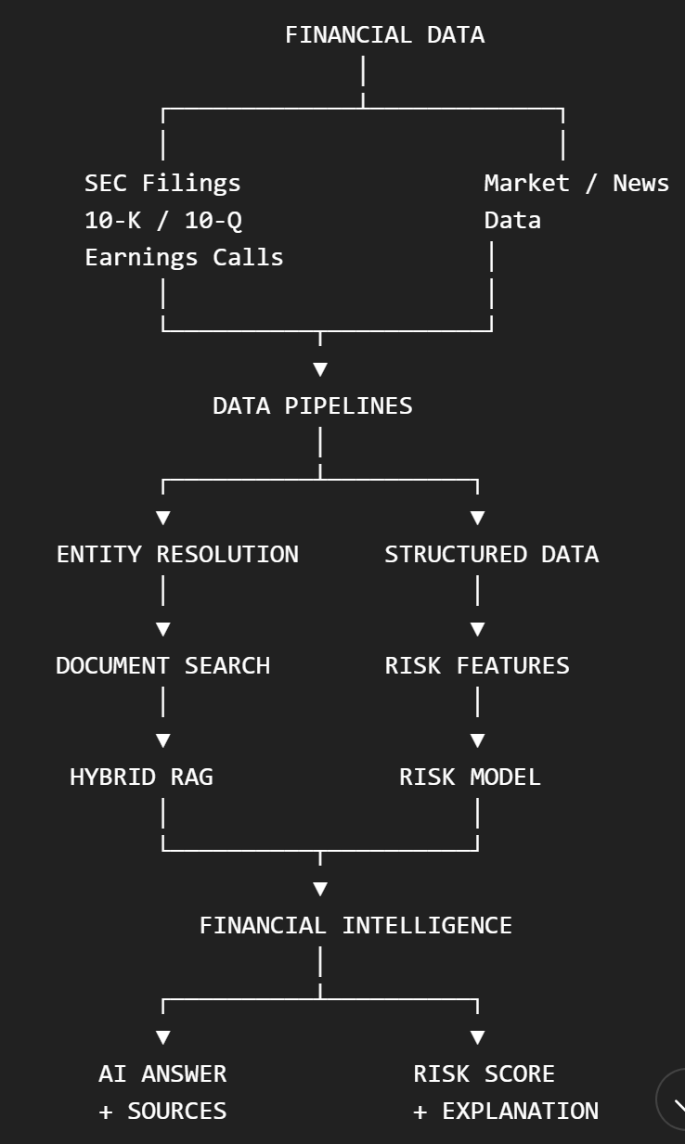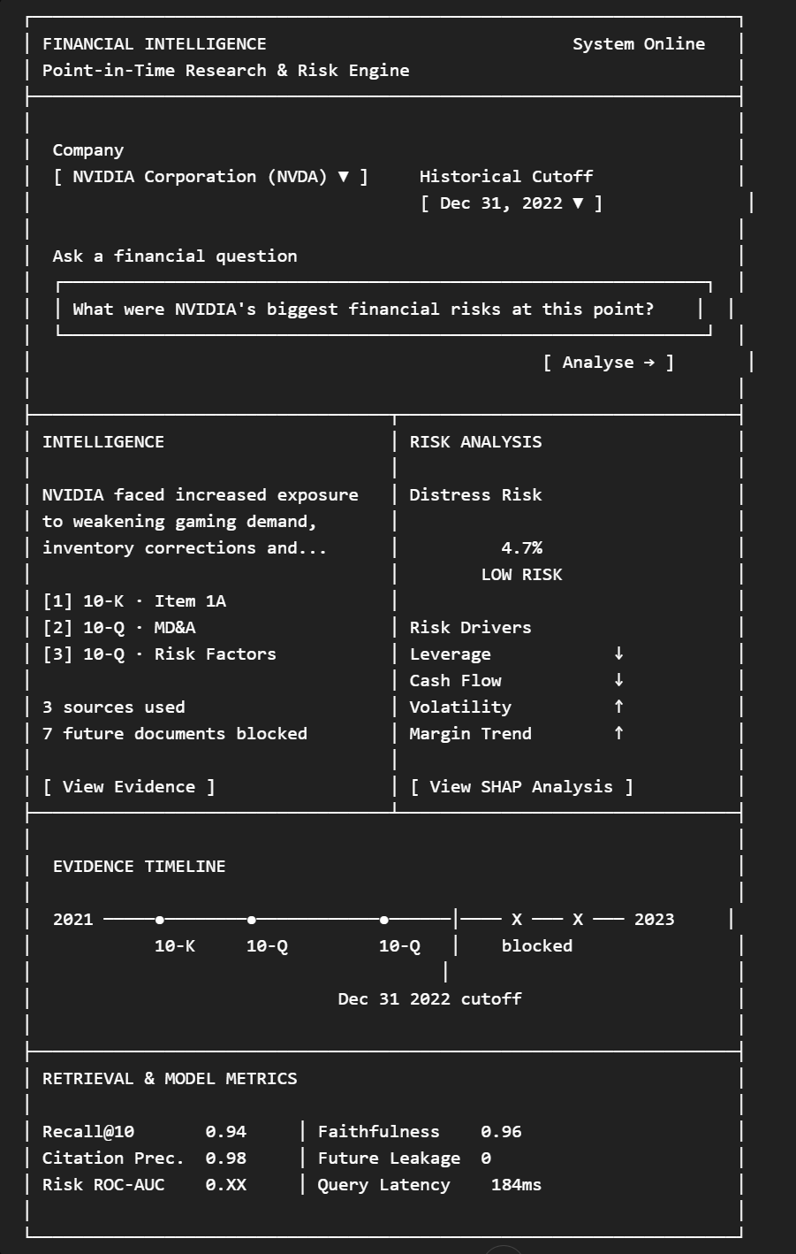

\resumeSubHeadingListStart

\resumeSubheading
{ZK Intelligence}{September 2026 - Present}
{Founder $|$ Machine Learning Engineer}{}
\resumeItemListStart
\resumeItem{Started an ML freelancing consultancy serving \textbf{3+} small businesses delivering ML services like lead-scoring, enquiry automations, and live reporting solutions; generating \textbf{£12k+ consultancy revenue}.}
\resumeItem{Designed, deployed and maintained ML systems like enquiry classification models, automated call-handling workflows and AI business assistants using Tensorflow, FastAPI, PostgreSQL, Docker and MLflow.}
\resumeItemListEnd

